MicroRNAs In Myocardial Infarction: Pathophysiological Mechanisms, Biomarker Utility, And Therapeutic Implications - A Systematic Review
Abstract
Background: MicroRNAs (miRNAs) are short non-coding RNAs that post-transcriptionally regulate gene expression and have emerged as key epigenetic modulators of myocardial infarction (MI). This review synthesized evidence on specific miRNAs governing MI pathophysiology and their translational relevance.
Methods: Four databases (PubMed, Scopus, Web of Science, and the Cochrane Library) were searched for studies published between 2015 and 2025, following PRISMA 2020. Human observational and experimental (animal or cardiomyocyte) studies reporting miRNA dysregulation and MI-related pathophysiological outcomes were included. Risk of bias was appraised using the Newcastle-Ottawa Scale, SYRCLE, and QUIPS tools.
Results: Twelve studies (5 human; 1,112 participants; 7 experimental) examining 11 miRNA entities were included. Circulating miR-499, miR-1, and miR-208a were up-regulated in MI and discriminated cases from controls with areas under the curve of 0.86, 0.863, and above 0.9, correlating with troponin and CK-MB (r = 0.488 to 0.495). A three-miRNA panel predicted 1-year major adverse cardiac events (AUC 0.865; event rate 18%). Experimentally, miR-208a and miR-34a promoted cardiomyocyte apoptosis, whereas down-regulated miR-133a was protective; miR-21 drove fibrosis through Smad7 and Jagged1; and miR-126 promoted angiogenesis via HIF-1α. Silencing miR-208a increased ejection fraction from 53.4% to 71.0% at 28 days.
Conclusion: Experimental evidence indicates that distinct miRNAs regulate apoptosis, fibrosis, angiogenesis, and ischemia-reperfusion injury in MI, whereas human studies primarily support diagnostic and prognostic associations. The evidence is limited by small samples, incomplete reporting of blinding, and heterogeneous study designs; therefore, interpretation should remain cautious.
Keywords: apoptosis; biomarkers; microRNAs; myocardial infarction; pharmacology.
Introduction
Myocardial infarction (MI) remains the single largest contributor to cardiovascular mortality, and ischemic heart disease accounted for the greatest share of the 19.8 million cardiovascular deaths recorded worldwide in 2022.¹ MI is defined as cardiomyocyte necrosis in the setting of acute myocardial ischemia, identified by a rising cardiac troponin pattern together with supporting clinical evidence; troponin is highly sensitive but rises with a delay and conveys little mechanistic information about the downstream injury.² Although reperfusion has transformed outcomes, the abrupt restoration of flow itself injures the myocardium, and the ensuing cascade of cardiomyocyte apoptosis, interstitial fibrosis, impaired angiogenesis, and adverse ventricular remodeling dictates infarct size and the progression to heart failure.³ These programs are increasingly recognized to be governed not only by the genome but by epigenetic regulation.⁴
MicroRNAs (miRNAs) are endogenous, approximately 22-nucleotide non-coding RNAs that bind target messenger RNAs to repress translation or direct their degradation, allowing a single miRNA to coordinate entire pathophysiological programs.⁵ In the cardiovascular system, tissue-enriched miRNAs regulate cardiac development, conduction, and the response to ischemic stress, and their dysregulation has been linked to virtually every form of heart disease.⁶ Among them, the muscle-enriched miR-1 and miR-133, the cardiac-specific miR-208 and miR-499, the pro-fibrotic miR-21, and the angiogenic miR-126 recur most consistently in ischemic myocardium. Because miRNAs are released into the circulation in a remarkably stable, protease-resistant form, they have also attracted attention as accessible biomarkers of myocardial injury.⁷ Yet the specific miRNAs that drive each distinct MI pathophysiological domain remain dispersed across the heterogeneous clinical and experimental literature, with no single consolidated synthesis.
This systematic review aimed to synthesize human and experimental evidence on the role of specific microRNAs as epigenetic regulators in the pathophysiology of myocardial infarction, focusing on cardiomyocyte apoptosis, fibrosis, remodeling, angiogenesis, ischemia-reperfusion injury, and their diagnostic and prognostic correlates.
Methods
Protocol and reporting
This systematic review was conducted and reported in accordance with the Preferred Reporting Items for Systematic Reviews and Meta-Analyses (PRISMA) 2020 statement.⁸ The review question was framed with the PECO structure (Population, Exposure, Comparison, Outcome). A review protocol was defined a priori; the review was not registered.
Eligibility criteria
Eligible studies examined microRNA expression or modulation in myocardial infarction. The population comprised patients with acute MI (STEMI, NSTEMI, or acute coronary syndrome) or suspected MI presenting with chest pain, and experimental MI models, namely rodent coronary-ligation or ischemia-reperfusion models and cardiomyocyte or endothelial cells under ischemia or hypoxia. The exposure was dysregulated miRNA expression (up- or down-regulation), including experimental gain-of-function (mimic or agomir) or loss-of-function (antagomir, sponge, or inhibitor) manipulation. Comparators were healthy controls, non-MI patients, sham-operated animals, or scrambled or negative-control transfection. Outcomes were MI-related pathophysiological processes (apoptosis, fibrosis, remodeling, ischemia-reperfusion injury, angiogenesis, inflammation) and related endpoints (infarct size, left-ventricular ejection fraction, major adverse cardiac events, and correlation with troponin or CK-MB). Only original studies published in English between 2015 and 2025 were included; reviews, editorials, and conference abstracts were excluded.
Information sources and search strategy
Four electronic databases (PubMed, Scopus, Web of Science, and the Cochrane Library) were searched for studies published from 2015 through 2025. The search combined controlled vocabulary and free-text terms for microRNAs, myocardial infarction, and pathophysiological processes using Boolean operators. Full database-specific search strategies and search documentation are provided in Additional file 1.
Study selection and data extraction
Records were deduplicated and screened by title and abstract against the eligibility criteria, after which full texts were assessed and the selection summarized in a PRISMA flow diagram (Figure 1). For each included study, data on authors, year, country, design, population or model, sample size, the miRNA studied and its direction of regulation, MI subtype or model, exposure or intervention, comparator, reported target/pathway or clinical correlate, pathophysiological domain, and quantitative outcomes were extracted into a standardized form.
Risk-of-bias assessment
Methodological quality was appraised with design-specific tools. Human case-control and cohort studies were assessed with the Newcastle-Ottawa Scale,⁹ the animal components of experimental studies were assessed with the SYRCLE risk-of-bias tool,¹⁰ and the prognostic-factor cohort was assessed with the Quality In Prognosis Studies (QUIPS) tool.¹¹ In-vitro components were synthesized descriptively and were not assigned a separate risk-of-bias score. Unusually high diagnostic or prognostic performance estimates were noted as interpretive cautions rather than formal risk-of-bias domains.
Data synthesis
Because of substantial heterogeneity in populations, models, miRNA assays, and outcome measures, a quantitative meta-analysis was not appropriate; findings were synthesized narratively and grouped by pathophysiological domain.
Results
Study selection
The four databases yielded 5,207 records (PubMed 1,121; Scopus 1,662; Web of Science 2,402; Cochrane Library 22). After 2,222 duplicates were removed, 2,985 records were screened by title and abstract, of which 2,898 were excluded. Of 87 reports sought for retrieval, 9 could not be obtained, leaving 78 assessed in full text; 66 were excluded (Figure 1). Twelve studies met the eligibility criteria, comprising 5 human observational studies (1,112 participants) and 7 experimental in vivo and in vitro studies.
Characteristics of the included studies
The 12 studies were published between 2015 and 2022; 11 were conducted in China and 1 in Romania. Five were human observational studies, enrolling 1,112 participants with reported mean or median ages of 44.7 to 68 years.¹²⁻¹⁶ Seven were experimental in vivo and in vitro studies using rodent coronary-ligation or ischemia-reperfusion models with parallel cardiomyocyte or endothelial-cell work.¹⁷⁻²³ Eleven reported miRNA labels/assays were identified; miR-21 and miR-21-5p were retained as separately reported by the original studies. Ten were up-regulated in MI, and miR-133a was down-regulated. The most frequently studied miRNA species/families were miR-21, miR-126, and miR-208a (2 studies each). All studies quantified miRNA by qRT-PCR (Table 1).
Risk of bias
Among the 7 experimental studies, 3 were judged at high risk of bias and 4 had predominantly unclear reporting in one or more SYRCLE domains, driven mainly by missing information on allocation concealment, random housing, and blinding (Figure 3). Of the 5 human studies, the prospective miR-1 cohort scored 7/9 on the Newcastle-Ottawa Scale (lowest risk), 3 case-control studies scored 6/9, and the prognostic-panel study was rated high risk on QUIPS owing to a small sample with 6 candidate predictors. Two reports yielded unusually high diagnostic or prognostic performance estimates; these findings were interpreted cautiously and were not treated as formal risk-of-bias domains.
Cardiomyocyte apoptosis
Three experimental studies addressed apoptosis. Tony et al. showed that miR-208a was up-regulated during ischemia and that its agomir increased, while its antagomir reduced, TUNEL-positive apoptosis; 28 days after MI, antagomir-treated mice had a higher left-ventricular ejection fraction than controls (71.0 +/- 5.60% vs 53.4 +/- 8.79%; sham 82.6 +/- 2.3%) and greater fractional shortening (35.0 +/- 4.2% vs 23.6 +/- 4.72%; all p < 0.05), with less fibrosis and hypertrophy, involving altered Bax and caspase-8 expression.¹⁷ By contrast, miR-133a fell after hypoxia-reoxygenation and ischemia-reperfusion, and its overexpression lowered the cardiomyocyte apoptosis rate by directly targeting DAPK2, whose luciferase signal decreased by roughly 50%.¹⁸ Pan et al. found miR-34a up-regulated after coronary ligation; mimic transfection increased and inhibitor transfection decreased apoptosis, the myocardial Bcl-2/Bax ratio declined while caspase-3 rose, and Notch1 was confirmed as a direct target (all p < 0.05).¹⁹
Myocardial fibrosis and remodeling
Two studies implicated miR-21 in post-infarction fibrosis. Yuan et al. reported that miR-21 was markedly elevated in the infarct zone, where mimic transfection activated cardiac fibroblasts and increased collagen I and α-smooth muscle actin, whereas inhibition reversed these changes; miR-21 acted by directly suppressing Smad7 within TGF-β1 signaling (p < 0.05).²⁰ Zhou et al. showed that an miR-21 sponge reduced myocardial fibrosis and the fibroblast-to-myofibroblast transformation markers α-smooth muscle actin and tensin, and improved cardiac function, by relieving repression of Jagged1 (p < 0.05).²¹ Consistent with a remodeling role, silencing miR-208a likewise attenuated interstitial fibrosis and hypertrophy 28 days after infarction.¹⁷
Angiogenesis
Two studies examined miR-126-driven angiogenesis. In exercise-trained MI rats, Song et al. found that HIF-1α up-regulated miR-126, increasing PCNA-positive/vWF-positive neovessels and reducing collagen volume fraction, with higher left-ventricular systolic pressure and lower end-diastolic pressure (p < 0.01); the HIF-1α inhibitor 2ME2 abolished these gains, and miR-126 acted through PIK3R2 and SPRED1 on the PI3K/AKT/eNOS axis.²² Gao et al. confirmed that miR-126 was highly expressed in ischemic myocardium, where a mimic increased VEGF, CD34, and endothelial tube formation while an inhibitor suppressed them; infarction reduced ejection fraction and fractional shortening and enlarged left-ventricular internal diameters (p < 0.01).²³
Ischemia-reperfusion injury
Ischemia-reperfusion injury was specifically modeled by Li et al., who combined 60 minutes of coronary occlusion with 120 minutes of reperfusion in rats and a parallel hypoxia-reoxygenation model in H9C2 cells; miR-133a decreased sharply after injury, and its restoration reduced apoptosis through DAPK2, identifying the miR-133a/DAPK2 axis as a protective node in reperfusion injury (p < 0.05).¹⁸
Inflammation
One inflammatory-signature study (Scarlatescu et al.) measured the immune-regulatory miRNAs miR-146a-5p, miR-223-3p, and miR-142-3p in 50 young STEMI patients; all three were elevated at baseline relative to controls and tracked the post-infarction inflammatory response.¹⁶
Diagnostic and prognostic correlates
Five human studies evaluated circulating miRNAs as diagnostic or prognostic markers. For early diagnosis, miR-499 yielded an area under the curve (AUC) of 0.86 (95% CI 0.81 to 0.91) at a cut-off of 4.79, with 80% sensitivity and 80.28% specificity, approaching cardiac troponin I (AUC 0.90) and detectable within 1 hour of chest-pain onset.¹² Circulating miR-1 reached an AUC of 0.863 (0.820 to 0.906; cut-off 2.215; sensitivity 87.9%, specificity 80.2%), rising to 0.931 (0.904 to 0.959) when combined with troponin I.¹³ miR-208a discriminated AMI from controls with an AUC above 0.9 and predicted treatment efficacy and adverse events with AUCs of 0.784 and 0.713, respectively.¹⁴ Diagnostic miRNAs correlated positively with established biomarkers: miR-499 with troponin I and CK-MB (r = 0.488 and 0.495; p < 0.001), and miR-208a with LDH, CK, and CK-MB.^{12,14} Prognostically, high miR-1 was associated with 720-day mortality (34/341 deaths, 9.97%) and 30-day major adverse cardiac events.¹³ In infarct-related-artery total occlusion, miR-21-5p and miR-126 were about 2.5-fold and 2.6-fold higher than in controls (3.616 vs 1.431 and 2.667 vs 1.04; p < 0.0001), with MACE in 9/51 patients (17.6%).¹⁵ A three-miRNA panel (miR-146a-5p, miR-223-3p, miR-142-3p) predicted 1-year MACE, which occurred in 9/50 young STEMI patients (18%); individual AUCs were 0.848, 0.832, and 0.732, and the combination reached 0.865.¹⁶ The mapping of each miRNA to its pathophysiological domain and translational relevance is shown in Figure 2, and the quantitative outcomes are summarized in Table 2.
Discussion
The most consistent signal across the experimental studies was the control of cardiomyocyte apoptosis. Up-regulated miR-208a and miR-34a were associated with pro-apoptotic signaling involving Bax/caspase-8 and Notch1, respectively, whereas the loss of miR-133a after reperfusion removed a brake on DAPK2-mediated death.¹⁷⁻¹⁹ These findings fit the established biology of miR-208a, an intronic, cardiac-specific miRNA that governs stress-dependent remodeling and conduction.²⁴ They also echo work showing that miR-34a accumulates in the aging and infarcted heart, where its inhibition reduces cell death and improves recovery.²⁵ Convergence of three independent groups on apoptosis, using complementary gain- and loss-of-function designs, strengthens causal inference, even though absolute effect sizes were reported inconsistently and often only in figures.
Fibrosis emerged as the second major theme, dominated by miR-21. Both rodent studies placed miR-21 upstream of myofibroblast activation, one through suppression of Smad7 within TGF-β1 signaling and the other through repression of Jagged1, and antagonism by sponge or inhibitor consistently reduced collagen deposition and improved function.^{20,21} This dual-target picture is congruent with the landmark observation that fibroblast miR-21 sustains ERK-MAP kinase signaling and interstitial fibrosis in the stressed heart.²⁶ A recent synthesis likewise positions miR-21 at the center of several pro-fibrotic axes.²⁷ The therapeutic corollary, that local miR-21 inhibition could limit adverse remodeling, is attractive but remains unproven in the human infarct setting.
Angiogenesis was the third domain, and here an up-regulated miRNA was beneficial. miR-126 promoted neovascularization and preserved ventricular pressures through the PI3K/AKT/eNOS and HIF-1α/VEGF axes, and exercise amplified this response in a HIF-1α-dependent manner.^{22,23} The direction of effect is biologically coherent, because miR-126 is the prototypical endothelial-enriched miRNA required for vascular integrity and angiogenic signaling.²⁸ That a non-pharmacological stimulus could increase endogenous miR-126 is clinically appealing, since it links exercise-based rehabilitation to a defined molecular mediator. Nonetheless, both studies used few animals, derived many outcomes from figures, and did not report blinded assessment, so the magnitude of benefit should be regarded as provisional.
Translationally, the human studies position circulating miRNAs as early and prognostic markers. miR-499, miR-1, and miR-208a separated infarction from controls with areas under the curve of 0.86 to above 0.9, correlated with troponin and CK-MB, and, for miR-1, added value when combined with troponin.¹²⁻¹⁴ These observations are consistent with the muscle-enriched origin of miR-1 and miR-133 and the arrhythmogenic role of miR-1 in ischemia.^{29,30} Prognostically, baseline miRNA panels were associated with 1-year major adverse cardiac events.^{15,16} However, some diagnostic estimates were unusually high, healthy volunteers rather than symptomatic non-infarction patients served as comparators in several studies, and the prognostic panels were derived in fewer than sixty patients. These factors raise concerns about spectrum bias, overfitting, and limited generalizability.
Pharmacological and translational implications
Taken together, experimental evidence suggests that selectively inhibiting or restoring certain miRNAs may attenuate features of infarct injury. From a pharmaceutical perspective, antagomirs or inhibitors may be relevant for pro-apoptotic or pro-fibrotic miRNAs, whereas mimic or replacement approaches may be relevant for protective miRNAs. Antisense chemistries with favorable pharmacokinetics for cardiovascular indications now exist.³¹ The first-in-human inhibition of miR-132 in patients with heart failure, rather than myocardial infarction specifically, reduced natriuretic peptides and narrowed the QRS, offering proof of principle for cardiovascular miRNA-directed therapy.³² The miRNAs identified here - the pro-apoptotic miR-208a and miR-34a, the pro-fibrotic miR-21, and the protective miR-133a and miR-126 - are plausible candidates for further preclinical development. The present review did not identify clinical interventional studies testing these MI-specific candidates. Translation will require cardiac-selective, durable delivery with minimal off-target effects, none of which the included preclinical studies were designed to assess.
Several limitations temper these conclusions. All but one study originated from a single country, the experimental work was uniformly small and rarely reported allocation concealment or blinding, and several human diagnostic studies used healthy controls rather than symptomatic non-infarction comparators. Small prognostic samples and unusually high performance estimates also limit confidence in clinical translation. Heterogeneity in models, miRNA assays, and outcome reporting precluded meta-analysis, so the synthesis remains narrative. The review nonetheless has strengths: a comprehensive four-database search, appraisal with design-appropriate tools, and explicit separation of experimental mechanistic evidence from human biomarker associations. Future work should prioritize multicenter human cohorts with symptomatic comparators, standardized normalization, adequately powered and blinded animal studies, and pre-registered analyses before these microRNAs enter clinical pathways.
Conclusion
Experimental evidence suggests that specific microRNAs regulate core pathophysiological programs of myocardial infarction, including apoptosis, fibrosis, angiogenesis, and reperfusion injury, whereas human studies primarily support diagnostic and prognostic associations. These miRNAs have therapeutic implications, but the current evidence is preliminary; rigorous, adequately powered, and transparently reported studies are required before clinical adoption.
References
1. Mensah GA, Fuster V, Murray CJL, et al. Global burden of cardiovascular diseases and risks, 1990-2022. J Am Coll Cardiol. 2023;82(25):2350-2473. doi: 10.1016/j.jacc.2023.11.007
2. Thygesen K, Alpert JS, Jaffe AS, et al. Fourth universal definition of myocardial infarction (2018). Circulation. 2018;138(20):e618-e651. doi: 10.1161/CIR.0000000000000617
3. Hausenloy DJ, Yellon DM. Myocardial ischemia-reperfusion injury: a neglected therapeutic target. J Clin Invest. 2013;123(1):92-100. doi: 10.1172/JCI62874
4. Chen J, Liu Z, Ma L, et al. Targeting epigenetics and non-coding RNAs in myocardial infarction: from mechanisms to therapeutics. Front Genet. 2021;12:780649. doi: 10.3389/fgene.2021.780649
5. Bartel DP. MicroRNAs: genomics, biogenesis, mechanism, and function. Cell. 2004;116(2):281-297. doi: 10.1016/S0092-8674(04)00045-5
6. Romaine SPR, Tomaszewski M, Condorelli G, Samani NJ. MicroRNAs in cardiovascular disease: an introduction for clinicians. Heart. 2015;101(12):921-928. doi: 10.1136/heartjnl-2013-305402
7. Mitchell PS, Parkin RK, Kroh EM, et al. Circulating microRNAs as stable blood-based markers for cancer detection. Proc Natl Acad Sci U S A. 2008;105(30):10513-10518. doi: 10.1073/pnas.0804549105
8. Page MJ, McKenzie JE, Bossuyt PM, et al. The PRISMA 2020 statement: an updated guideline for reporting systematic reviews. BMJ. 2021;372:n71. doi: 10.1136/bmj.n71
9. Wells GA, Shea B, O'Connell D, et al. The Newcastle-Ottawa Scale (NOS) for assessing the quality of nonrandomised studies in meta-analyses. Ottawa: Ottawa Hospital Research Institute; 2021. Available from: https://www.ohri.ca/programs/clinical_epidemiology/oxford.asp
10. Hooijmans CR, Rovers MM, de Vries RBM, Leenaars M, Ritskes-Hoitinga M, Langendam MW. SYRCLE's risk of bias tool for animal studies. BMC Med Res Methodol. 2014;14:43. doi: 10.1186/1471-2288-14-43
11. Hayden JA, van der Windt DA, Cartwright JL, Cote P, Bombardier C. Assessing bias in studies of prognostic factors. Ann Intern Med. 2013;158(4):280-286. doi: 10.7326/0003-4819-158-4-201302190-00009
12. Zhang L, Chen X, Su T, et al. Circulating miR-499 are novel and sensitive biomarker of acute myocardial infarction. J Thorac Dis. 2015;7(3):303-308. doi: 10.3978/j.issn.2072-1439.2015.02.05
13. Su T, Shao X, Zhang X, Han Z, Yang C, Li X. Circulating microRNA-1 in the diagnosis and predicting prognosis of patients with chest pain: a prospective cohort study. BMC Cardiovasc Disord. 2019;19(1):5. doi: 10.1186/s12872-018-0987-x
14. Chen S, Hong X, Wu Y, Chen Z. Diagnostic and prognostic significance of microRNA-208a in acute myocardial infarction. Dis Markers. 2022;2022:7030722. doi: 10.1155/2022/7030722
15. Mi X, Gao Y, Hao D, et al. Prognostic value of circulating microRNA-21-5p and microRNA-126 in patients with acute myocardial infarction and infarct-related artery total occlusion. Front Cardiovasc Med. 2022;9:947721. doi: 10.3389/fcvm.2022.947721
16. Scarlatescu AI, Barbalata T, Sima AV, Stancu C, Niculescu LS, Micheu MM. miR-146a-5p, miR-223-3p and miR-142-3p as potential predictors of major adverse cardiac events in young patients with acute ST elevation myocardial infarction. Diagnostics (Basel). 2022;12(8):1946. doi: 10.3390/diagnostics12081946
17. Tony H, Meng K, Wu B, et al. MicroRNA-208a dysregulates apoptosis genes expression and promotes cardiomyocyte apoptosis during ischemia and its silencing improves cardiac function after myocardial infarction. Mediators Inflamm. 2015;2015:479123. doi: 10.1155/2015/479123
18. Li S, Xiao FY, Shan PR, et al. Overexpression of microRNA-133a inhibits ischemia-reperfusion-induced cardiomyocyte apoptosis by targeting DAPK2. J Hum Genet. 2015;60(11):709-716. doi: 10.1038/jhg.2015.96
19. Pan J, Zhou L, Lin C, Xue W, Chen P, Lin J. MicroRNA-34a promotes ischemia-induced cardiomyocytes apoptosis through targeting Notch1. Evid Based Complement Alternat Med. 2022;2022:1388415. doi: 10.1155/2022/1388415
20. Yuan J, Chen H, Ge D, et al. Mir-21 promotes cardiac fibrosis after myocardial infarction via targeting Smad7. Cell Physiol Biochem. 2017;42(6):2207-2219. doi: 10.1159/000479995
21. Zhou XL, Xu H, Liu ZB, Wu QC, Zhu RR, Liu JC. miR-21 promotes cardiac fibroblast-to-myofibroblast transformation and myocardial fibrosis by targeting Jagged1. J Cell Mol Med. 2018;22(8):3816-3824. doi: 10.1111/jcmm.13654
22. Song W, Liang Q, Cai M, Tian Z. HIF-1a-induced up-regulation of microRNA-126 contributes to the effectiveness of exercise training on myocardial angiogenesis in myocardial infarction rats. J Cell Mol Med. 2020;24(22):12970-12979. doi: 10.1111/jcmm.15892
23. Gao S, Gao H, Dai L, et al. miR-126 regulates angiogenesis in myocardial ischemia by targeting HIF-1a. Exp Cell Res. 2021;409(2):112925. doi: 10.1016/j.yexcr.2021.112925
24. van Rooij E, Sutherland LB, Qi X, Richardson JA, Hill J, Olson EN. Control of stress-dependent cardiac growth and gene expression by a microRNA. Science. 2007;316(5824):575-579. doi: 10.1126/science.1139089
25. Boon RA, Iekushi K, Lechner S, et al. MicroRNA-34a regulates cardiac ageing and function. Nature. 2013;495(7439):107-110. doi: 10.1038/nature11919
26. Thum T, Gross C, Fiedler J, et al. MicroRNA-21 contributes to myocardial disease by stimulating MAP kinase signalling in fibroblasts. Nature. 2008;456(7224):980-984. doi: 10.1038/nature07511
27. Khalaji A, Mehrtabar S, Jabraeilipour A, et al. Inhibitory effect of microRNA-21 on pathways and mechanisms involved in cardiac fibrosis development. Ther Adv Cardiovasc Dis. 2024;18:17539447241253134. doi: 10.1177/17539447241253134
28. Wang S, Aurora AB, Johnson BA, et al. The endothelial-specific microRNA miR-126 governs vascular integrity and angiogenesis. Dev Cell. 2008;15(2):261-271. doi: 10.1016/j.devcel.2008.07.002
29. Chen JF, Mandel EM, Thomson JM, et al. The role of microRNA-1 and microRNA-133 in skeletal muscle proliferation and differentiation. Nat Genet. 2006;38(2):228-233. doi: 10.1038/ng1725
30. Yang B, Lin H, Xiao J, et al. The muscle-specific microRNA miR-1 regulates cardiac arrhythmogenic potential by targeting GJA1 and KCNJ2. Nat Med. 2007;13(4):486-491. doi: 10.1038/nm1569
31. van Rooij E, Olson EN. MicroRNA therapeutics for cardiovascular disease: opportunities and obstacles. Nat Rev Drug Discov. 2012;11(11):860-872. doi: 10.1038/nrd3864
32. Taubel J, Hauke W, Rump S, et al. Novel antisense therapy targeting microRNA-132 in patients with heart failure: results of a first-in-human Phase 1b randomized, double-blind, placebo-controlled study. Eur Heart J. 2021;42(2):178-188. doi: 10.1093/eurheartj/ehaa898
Tables
Table 1. Characteristics of the 12 included studies.¹²⁻²³
Study (Year) | Country | Design | Population / model (n) | miRNA (reg.) | Domain | Target/pathway or clinical correlate
Zhang, 2015 | China | Case-control | Chest pain (AMI 142 / non-AMI 85 / HC 100) | miR-499 (↑) | Diagnosis | Cardiac-specific marker
Su, 2019 | China | Prospective cohort | Acute chest pain (AMI 174 / non-AMI 167 / control 100) | miR-1 (↑) | Diagnosis, prognosis | cTnI correlation
Chen, 2022 | China | Case-control | AMI post-PCI 84 + HC 50 | miR-208a (↑) | Diagnosis, prognosis | Senescence; mTOR; Wnt
Mi, 2022 | China | Case-control | STEMI (IR-ATO/IR-BVR) 100 + HC 50 | miR-21-5p, miR-126 (↑) | Prognosis (MACE) | PTEN; PI3K/AKT
Scarlatescu, 2022 | Romania | Prospective cohort | Young STEMI 50 + HC 10 | miR-146a-5p, miR-223-3p, miR-142-3p (↑) | Inflammation, prognosis | Immune regulation
Tony, 2015 | China | Animal + in vitro | C57BL/6 mice + cardiomyocytes (6-7/grp) | miR-208a (↑) | Apoptosis, fibrosis, remodeling | Bax; caspase-8
Li, 2015 | China | Animal + in vitro | Wistar rats + H9C2 (10/grp) | miR-133a (↓) | Apoptosis; I/R injury | DAPK2
Pan, 2022 | China | Animal + in vitro | SD rats + cardiomyocytes (8/grp) | miR-34a (↑) | Apoptosis | Notch1; Bcl-2/Bax
Yuan, 2017 | China | Animal + in vitro | C57BL/6 mice + cardiac fibroblasts (9-18) | miR-21 (↑) | Fibrosis | Smad7; TGF-β1
Zhou, 2018 | China | Animal + in vitro | SD rats + cardiac fibroblasts (3/grp) | miR-21 (↑) | Fibrosis, remodeling | Jagged1; Notch
Song, 2020 | China | Animal + in vitro | SD rats + HUVECs (7/grp) | miR-126 (↑) | Angiogenesis | PIK3R2/SPRED1; PI3K/AKT/eNOS
Gao, 2021 | China | Animal + in vitro | SD rats + EA.hy926 (15/grp) | miR-126 (↑) | Angiogenesis | HIF-1α; VEGF
AMI, acute myocardial infarction; CK-MB, creatine kinase-MB; cTnI, cardiac troponin I; eNOS, endothelial nitric oxide synthase; HC, healthy control; HUVEC, human umbilical vein endothelial cell; IR-ATO, infarct-related artery total occlusion; IR-BVR, infarct-related blood-vessel recanalization; I/R, ischemia-reperfusion; MACE, major adverse cardiac events; PCI, percutaneous coronary intervention; SD, Sprague-Dawley; STEMI, ST-elevation myocardial infarction; TGF-β1, transforming growth factor-b1; VEGF, vascular endothelial growth factor. Arrows denote up-regulation (↑) or down-regulation (↓). All studies quantified miRNA by qRT-PCR.

Table 2. Summary of quantitative outcomes for each included study.¹²⁻²³
Study (Year) | miRNA (reg.) | Domain | Key quantitative finding | Effect estimate | P
Zhang, 2015 | miR-499 (↑) | Diagnosis | Detectable 1 h post-onset; cut-off 4.79; Sens 80%, Spec 80.28% | AUC 0.86 (0.81-0.91); r 0.488-0.495 | <0.001
Su, 2019 | miR-1 (↑) | Diagnosis, prognosis | Adds value to cTnI; 720-d deaths 34/341 (9.97%) | AUC 0.863; combined 0.931 | <0.001
Chen, 2022 | miR-208a (↑) | Diagnosis, prognosis | Falls after therapy; predicts efficacy/adverse events | AUC >0.9; 0.784; 0.713 | <0.05
Mi, 2022 | miR-21-5p, miR-126 (↑) | Prognosis (IR-ATO) | miR-21-5p 3.616 vs 1.431; MACE 9/51 (17.6%) | Fold ~2.5-2.6 vs control | <0.0001
Scarlatescu, 2022 | miR-146a-5p/223-3p/142-3p (↑) | Inflammation, prognosis | 1-y MACE 9/50 (18%); 3-miRNA panel | AUC 0.848/0.832/0.732; panel 0.865 | 0.001-0.031
Tony, 2015 | miR-208a (↑) | Apoptosis, remodeling | Antagomir raised EF 53.4 to 71.0%; less fibrosis/hypertrophy | EF +17.6 points | <0.05
Li, 2015 | miR-133a (↓) | Apoptosis, I/R injury | Mimic lowered apoptosis; DAPK2 luciferase down ~50% | Direct target validated | <0.05
Pan, 2022 | miR-34a (↑) | Apoptosis | Caspase-3 up, Bcl-2/Bax down; Notch1 target | Direct target validated | <0.05
Yuan, 2017 | miR-21 (↑) | Fibrosis | Collagen-I and α-SMA up; Smad7 target (TGF-β1) | Direct target validated | <0.05
Zhou, 2018 | miR-21 (↑) | Fibrosis, remodeling | Sponge lowered fibrosis and CMT markers; Jagged1 target | Direct target validated | <0.05
Song, 2020 | miR-126 (↑) | Angiogenesis | Exercise raised HIF-1α/miR-126; PCNA+/vWF+ up; CVF down | HIF-1α-dependent | <0.01
Gao, 2021 | miR-126 (↑) | Angiogenesis | Mimic raised VEGF, CD34, tube formation | HIF-1α/VEGF axis | <0.01
AUC, area under the receiver-operating-characteristic curve; α-SMA, α-smooth muscle actin; CK, creatine kinase; CK-MB, creatine kinase-MB; CMT, cardiac fibroblast-to-myofibroblast transformation; cTnI, cardiac troponin I; CVF, collagen volume fraction; EF, ejection fraction; IR-ATO, infarct-related artery total occlusion; I/R, ischemia-reperfusion; LDH, lactate dehydrogenase; MACE, major adverse cardiac events; r, correlation coefficient; Sens, sensitivity; Spec, specificity. Arrows denote up-regulation (↑) or down-regulation (↓).
Figure legends
Figure 1. PRISMA 2020 flow diagram of study selection.
Figure 2. MicroRNA mechanisms, clinical utility, and potential pharmaceutical targeting in myocardial infarction. Up arrows indicate increased expression and down arrows indicate reduced expression. Pathways listed were reported in the included studies.
Figure 3. Summary of methodological appraisal and reporting limitations. Animal components of experimental studies were assessed using SYRCLE; human observational studies used the Newcastle-Ottawa Scale or QUIPS, as appropriate. In-vitro components were synthesized descriptively and were not separately scored. Caution flags denote unusually high diagnostic or prognostic performance estimates and are not determinations of article-level integrity.
Figures
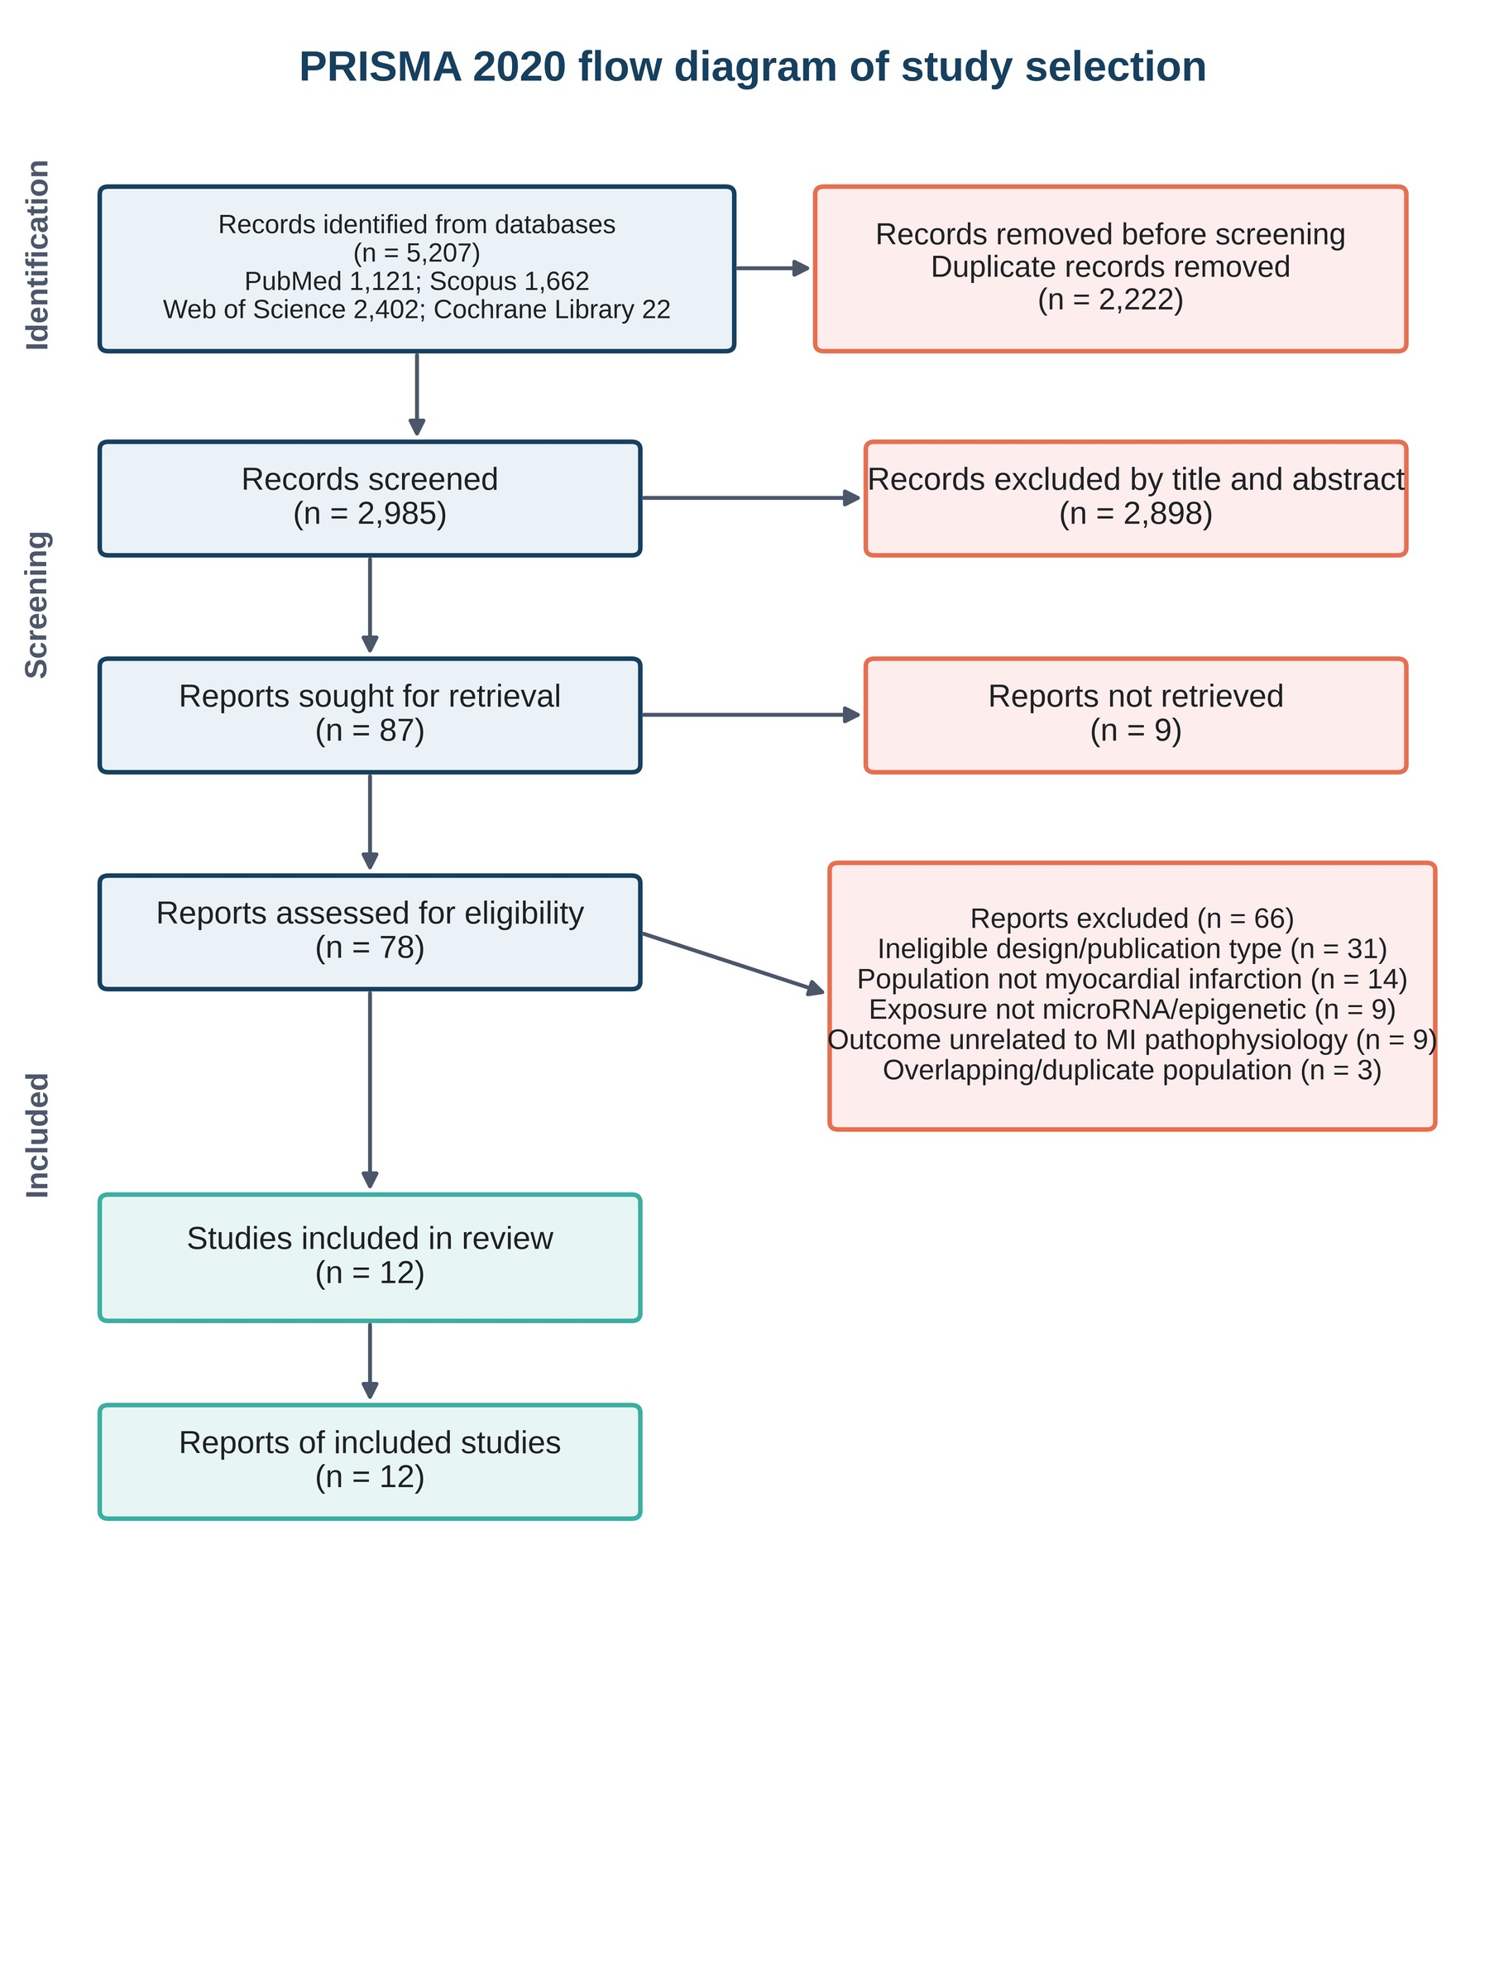
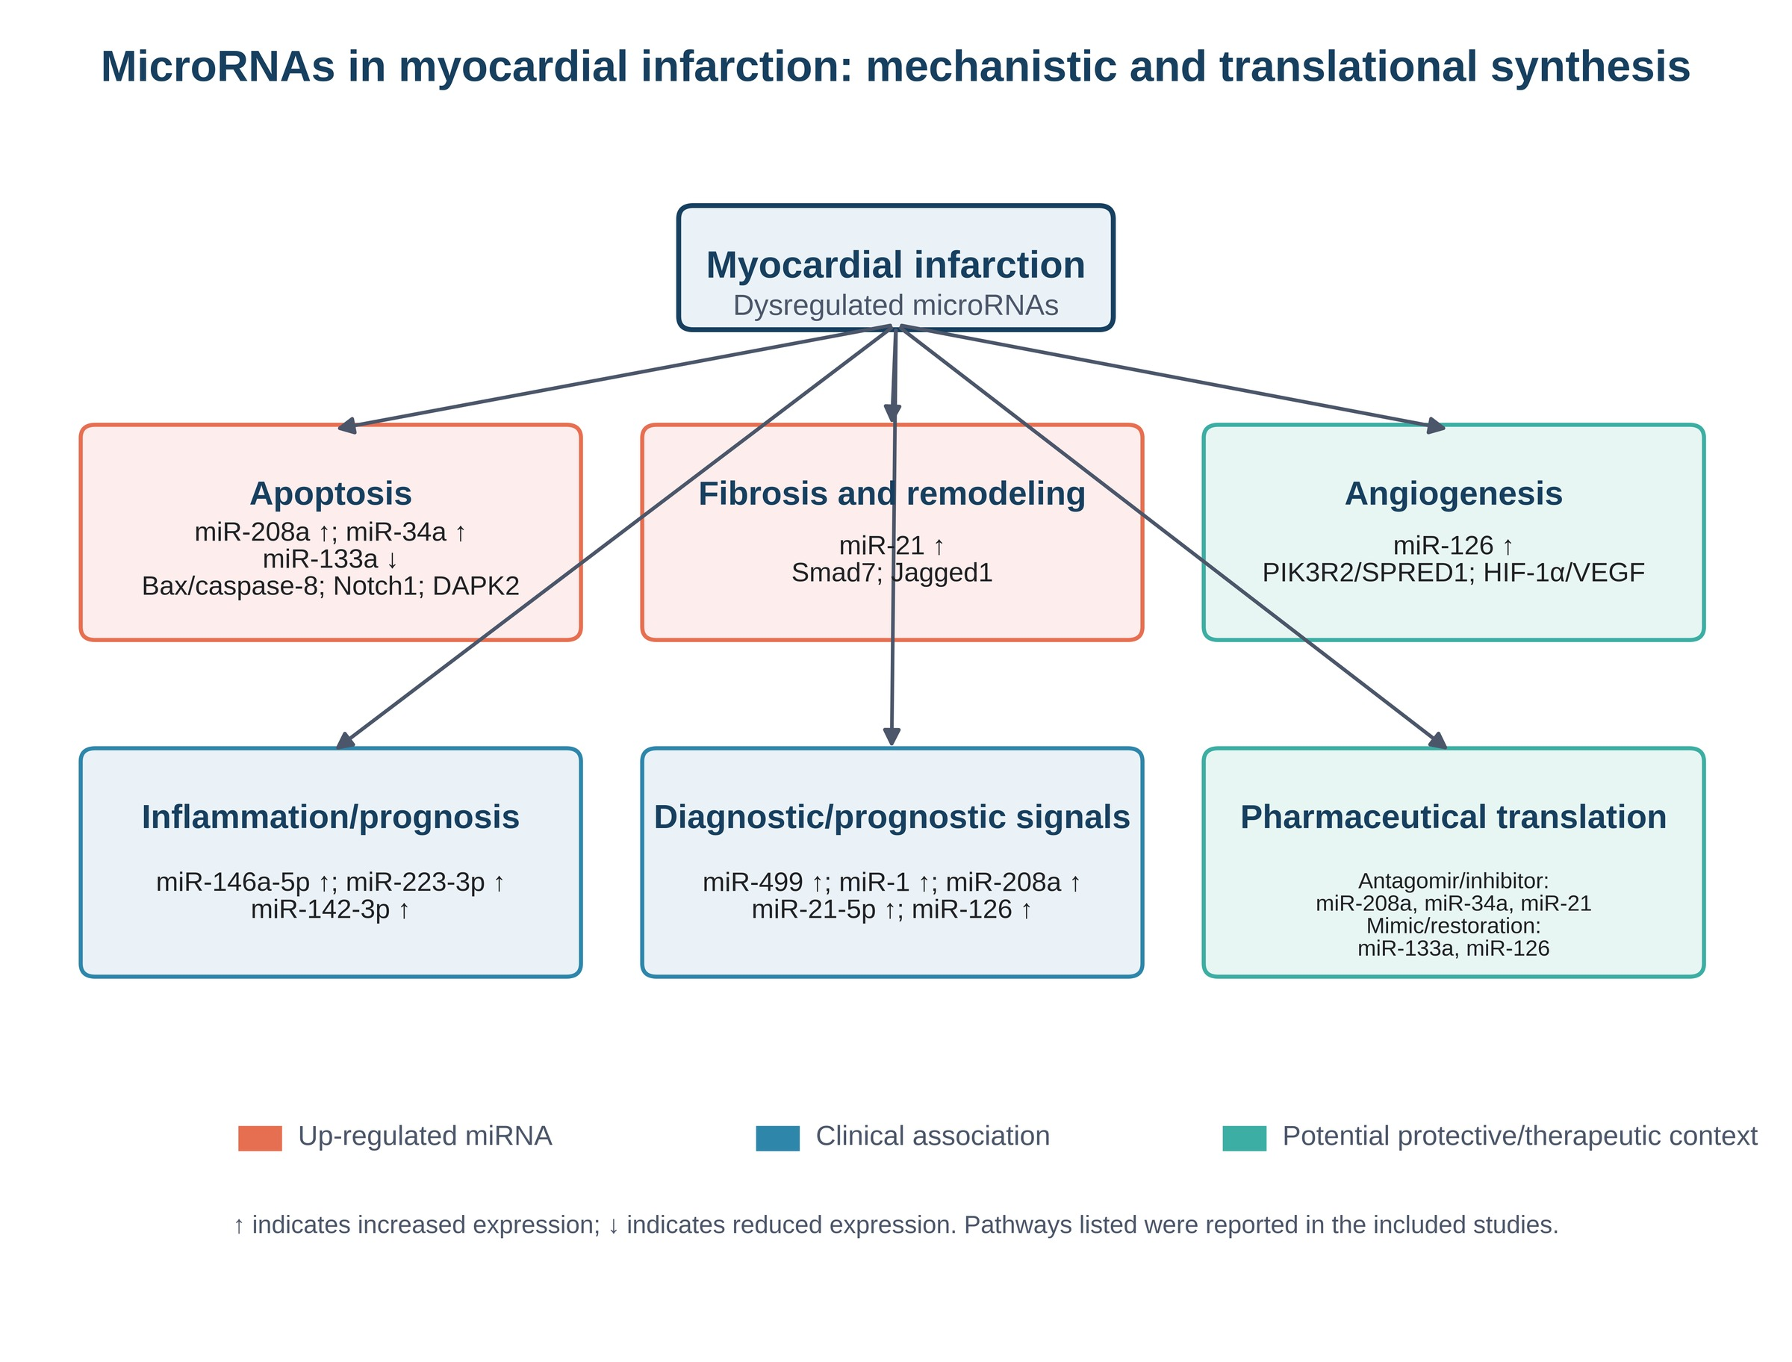
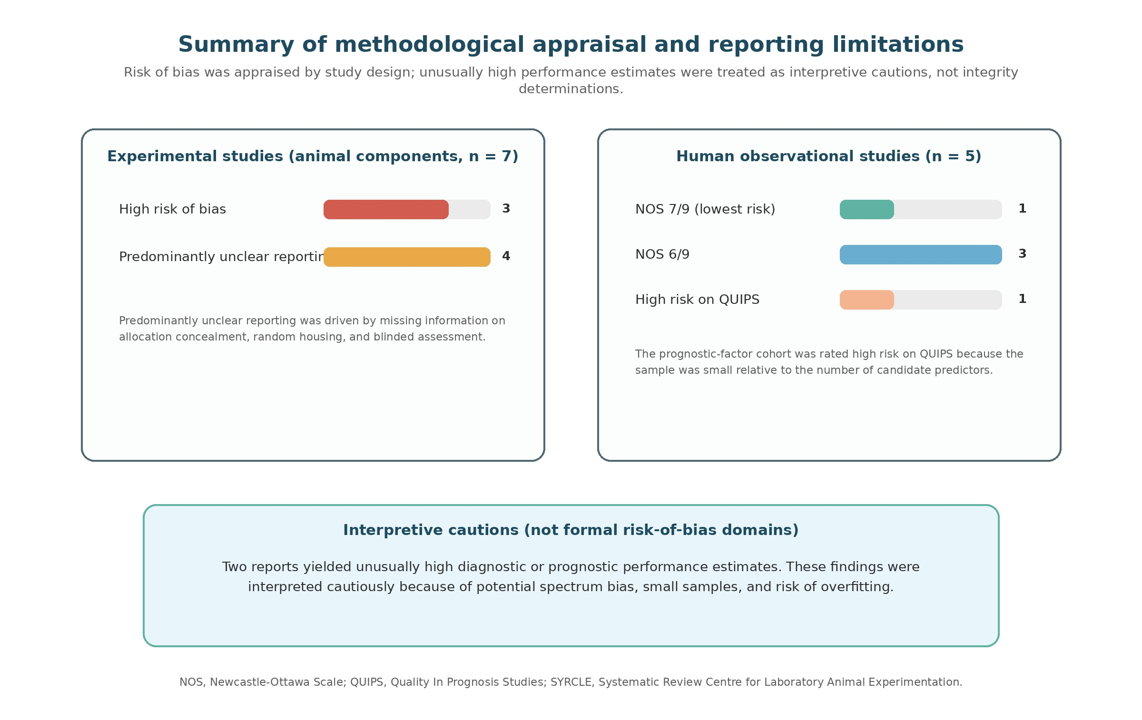
List of additional files
Additional file 1. Detailed electronic search strategy and search documentation.
Additional file 2. PRISMA 2020 checklist.

